Experiment # 13

**Building Simple Network Topologies using Packet Tracer**

**Objective:**

* To understand basic networking Topologies
* Implementation of Topologies on Packet Tracer.

**Tools:**

* Cisco Packet Tracer

Theory:

Network topology is the arrangement of the various elements of a computer network.

**Bus topology:** All devices are connected to a central cable, called the bus or backbone. Bus networks are relatively inexpensive and easy to install for small networks.

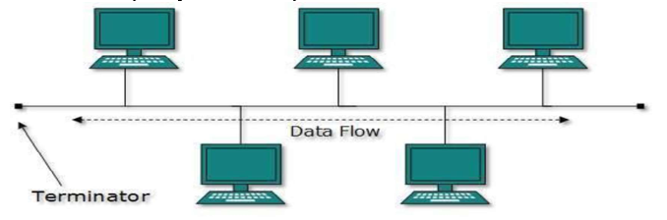

Connect Four PC’s using switches and join them using switches.

Assign each PC with the address of Class B and then Ping each PC to check weather communication is being done or not.

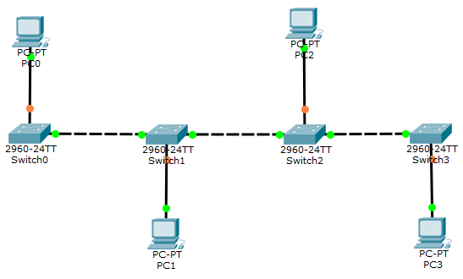

**Ring topology:** All devices are connected to one another in the shape of a closed loop, so that each device is connected directly to two other devices, one on either side of it. Ring topologies are relatively expensive and difficult to install, but they offer high bandwidth and can span large distances.

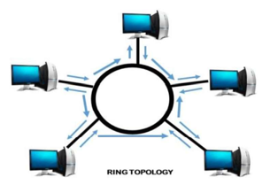

Assign each PC with the address of Class A.

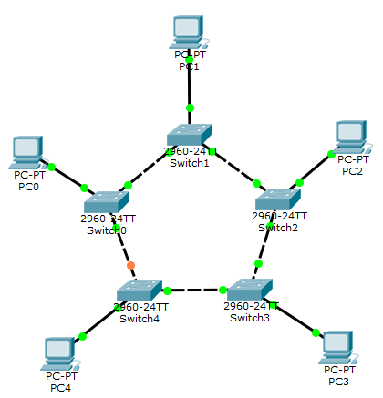

**Star topology:** A star topology is a topology for a Local Area Network (LAN) in which all nodes are individually connected to a central connection point, like a hub or a switch. A star takes more cable than e.g. a bus, but the benefit is that if a cable fails, only one node will be brought down.

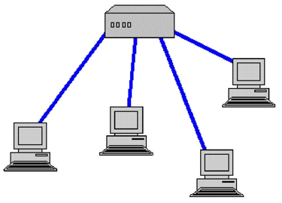

Connect each PC with a switch and give each PC addresses of Class A.

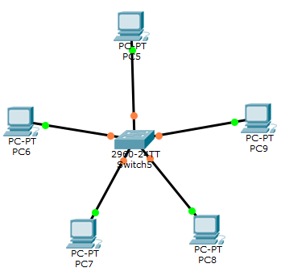

**Mesh topology:** A network setup where each computer and network device is interconnected with one another, allowing most transmissions to be distributed, even if one of the connections go down. This topology is not commonly used for most computer networks, as it is difficult and expensive to have redundant connection to every computer. However, this topology is commonly used for wireless networks.

Below is a visual example of a simple computer setup on a network using a mesh topology

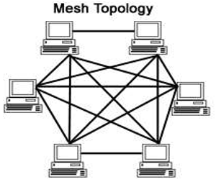

Make following network and assign each PC addresses from Class C.

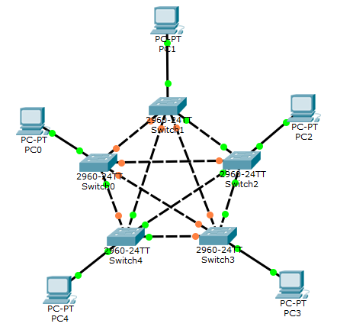

**Hybrid topology:** A topology, which contain more than one of upper topology or it, is the mixture of above topologies.

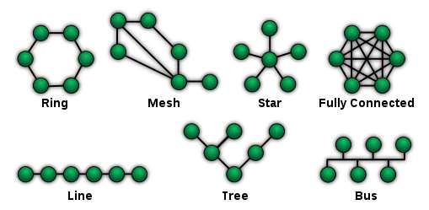

**Lab Tasks**

1. Design a network having 8 PC’s (which means each PC is connected to different switch) and connect them using Tree Topology. Assign each PC an address range from 192.168.30.2 to 192.168.30.9.
2. What is the difference b/w public and private IP address? Give IP ranges and number of hosts for private IP addresses in each class.
3. Design a hybrid topology having more than 5 PC’s by using any two of above four topologies.